Kindergarten School Supply List
Evelyn Dickson 2026-2027

2 Interlined Notebooks – Half and Half | 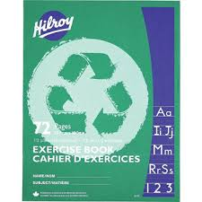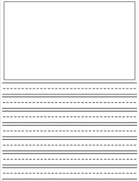 | 2 Duo-Tangs –  1 Red and 1 Blue | 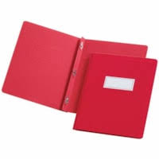
5 Pencils | 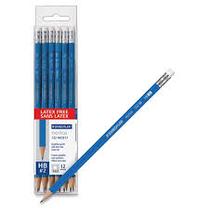 | 2 Scrapbook -Coil Bound | 
2 boxes of Washable Markers | 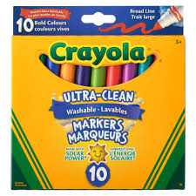 | 1 Pair of Scissors (Blunt for K) | 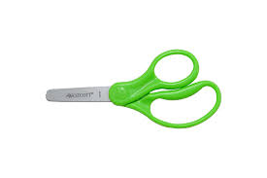
2 White Erasers | 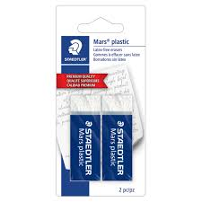 | 6 Glue Stick (large) | 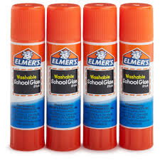
1 set of Pencil Crayons | 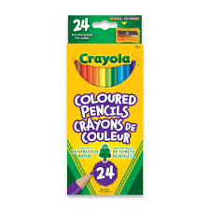 | 1 box of wax crayons | 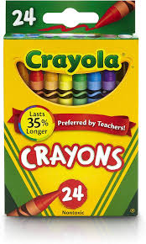
1 Pencil Box | 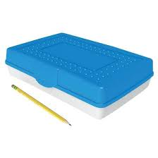 | 1 Box of Kleenex | 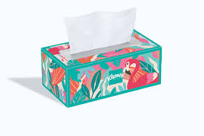
1 Pair of Inside Shoes (runners with non-marking soles and NO laces that need to be tied) | 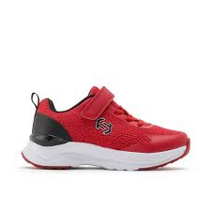 | 1 Change of Clothes for emergencies (in a large Ziploc bag) | 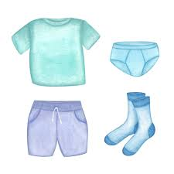
1 Computer Compatible Headset (in a large Ziploc bag) | 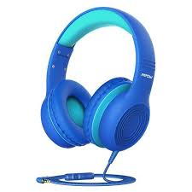 | 1 Set of disc watercolor paints | 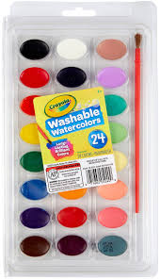
1 Box of Bandaids | 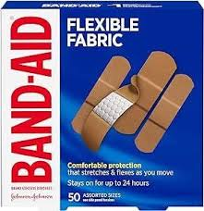 | 6 Dry Erase Markers - Thin | 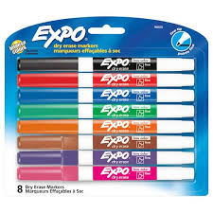
2 Plain Double Pocket Plastic folders | 