

Evelyn Dickson Elementary School
2024-2025
School Plan to Enhance Student Learning

Purpose and Vision:
To align our goals to the SD 91 District Strategic Plan of:
- Create Student Success (Literacy, Numeracy, Social Emotional Learning)
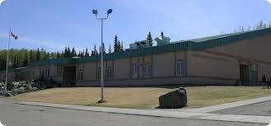
- Honour Diversity
- Enhance Connections
- Engage our Workforce

About Us
Our Story
We are proud to provide a rich learning environment for students on the unceded traditional territory of the Saik'uz First Nation. First opened in 1973, Evelyn Dickson Elementary School (EDS) is a K-6 elementary school set in an established neighborhood on the south side of beautiful Vanderhoof, British Columbia. The school is named after Mrs. Evelyn Dickson, a long-time resident of Vanderhoof, in honour of her 32.5 years of dedication to students.
EDS is extremely fortunate to have a passionate and invested staff, and strong parental involvement in our PAC and school activities and traditions.
Our school mascot is the Vi-Kid, and our Motto is:
At EDS We C.A.R.E.
We are a Community of Learners that focuses on:
*Acceptance*Achievement*Respect*Responsibility*pursuit of Excellence*
Our Learners
Our school population of approximately 190 K-6 learners are served by our thirty staff members in an area that has access to green spaces and trails as well as other unique learning spaces that enrich students' learning. Access to the outdoors, including our garden area, promotes rich learning experiences, environmental respect and healthy living through exploration and connection to nature. Our teachers offer many extracurricular activities and sports to our diverse student population. Students of Indigenous ancestry make up 30% of our learning community and 10% of our students are English Language learners. We take pride in meeting our students where they are at and helping them find their full potential.

Our school plan aligns with the SD 91 Strategic Plan, emphasizing literacy and numeracy. These areas are key in connecting the Core Competencies with the Curricular Competencies, fostering the development of confident, effective communicators and critical thinkers. Literacy and numeracy are foundational to the British Columbia curriculum, as they are vital for success both in education and in life. They equip students with the skills to think critically, communicate clearly, and actively engage in society.

Goal 1: Literacy

Our students will be proficient in grade level district assessments (PM Benchmarks, CCR, FSA).

Aligns with SD 91 priority: Create Student Success: A continued focus on the essential skills of literacy, numeracy, and social emotional well-being.

Current reality/What does the data tell us?
Primary: Our Early Years Evaluation (EYE) data shows that our learners are entering Kindergarten less prepared for school. Our grade 1-3 PM Benchmarks data reflects this as it indicates a decrease in the number of grade 3 students who are proficient /extending.
Intermediate: Our data (FSA, CCR) indicates a decreasing number of learners who are proficient/extending.

Our response to the data:
We have focused on building skills with targeted interventions and teaching strategies. These include:
- K-3 - daily targeted LSW intervention in classroom small group and 1:1
- K-3 - daily embedded phonic lessons, sound/letter knowledge lessons and practice
- K/1 - daily Heggerty lessons
- K/1 - focused letter fluency lessons
- 1-6 - weekly (2x) targeted ELL intervention for our English Second Language learners.
- 4-6 - small weekly group intervention focuses on phonics and sight words
- 4-6 - bi-weekly 1:1 focus on phonics and sight words
- 4-6 Focus on Main Idea and Details
- Literacy Collaboration with Michelle Miller-Gauthier District Literacy Support Teacher

What is next?
Using the strategies and interventions noted above:
Primary: Develop student's phonemic awareness, letter recognition and sight word skills.
Intermediate: Develop student skills in identifying main ideas and supporting details.

How will we know if we meet our goal:
Grade 1: Term 3 PM Benchmark Reading Assessment level 15 or greater
Grade 2: Term 3 PM Benchmark Reading Assessment level 20 or greater
Grade 3: Term 1 PM Benchmark Reading Assessment level of 24 or greater.
Grade 4: Grade 4 Foundational Skills Assessment evaluation of on-track or extending in literacy.
Grade 5: SD91 Cross-Curricular Reading Assessment evaluation of proficient or extending.

Data: Literacy
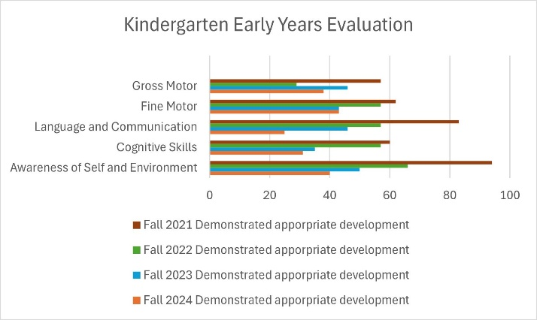

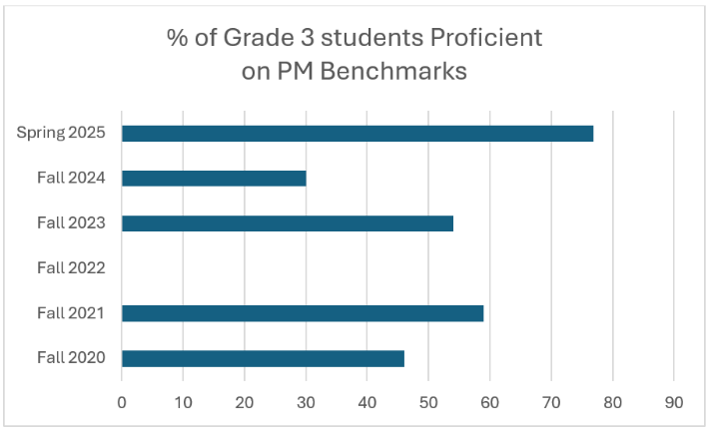
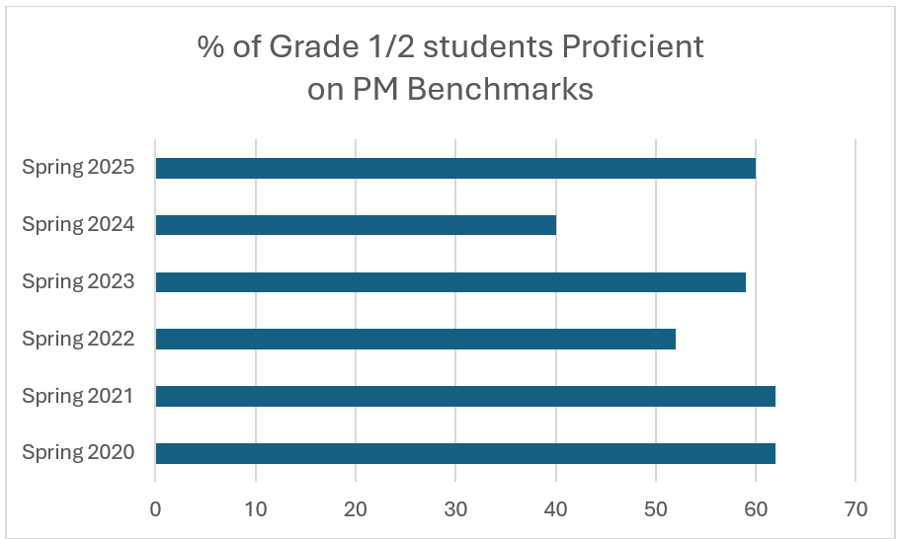

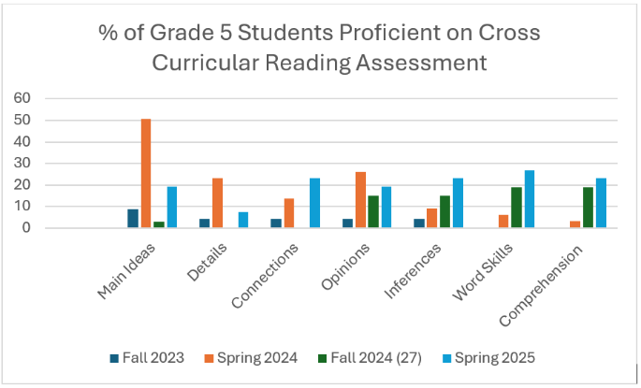

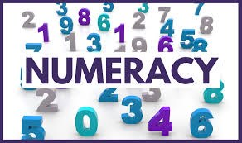

Goal 2: Numeracy

Our students will be proficient in grade level

district assessments (SNAP, DNA, FSA).
Aligns with SD 91 priority: Create Student Success: A continued focus on the essential skills of literacy, numeracy, and social emotional well-being.

Current reality/What does the data tell us?
Our school data and teacher observations indicate that students are lacking foundational skills in numeracy. Based on the DNA data, we are seeing growth in grade 3, but by grade 6, less than 10% of our students are proficient. Our grade 4 FSA Data reflects that half of our grade four students are not on track in numeracy.
Our response to the data:
We have focused on building skills with targeted interventions and teaching strategies. These include:
- K-3: Morning calendar, numeracy word problems.
- K-3: Use of manipulatives.
- K-3: Addition/Subtraction Strategies
- K-3: Estimation
- SNAP Math
- Individual practices on small whiteboards
- Rotating groups- solve & check answer.
- Math talks - introduction of strategies - discussion and practice
- Use of manipulatives in the classroom
- Reinforce/scaffold skills through games.
- Numeracy focused collaboration with colleagues
- Thinking classroom strategies
- Numeracy focused collaboration with Lena Miller - District Numeracy Support Teacher
What is next?
Using the strategies and interventions noted above:
Primary: Develop student's number sense with a focus on grade-by-grade number sense curriculum.
Intermediate: Develop students’ numeracy foundations in multiple ways, by focusing on computational fluency in addition, subtraction, multiplication, and division.
How will we know if we meet our goal:
Primary: End of Term District Numeracy Assessment - proficient or extending.
Grade 4: Grade 4 Foundational Skills Assessment evaluation of on-track or extending in numeracy. End of Term District Numeracy Assessment of proficient or extending.

Data: Numeracy
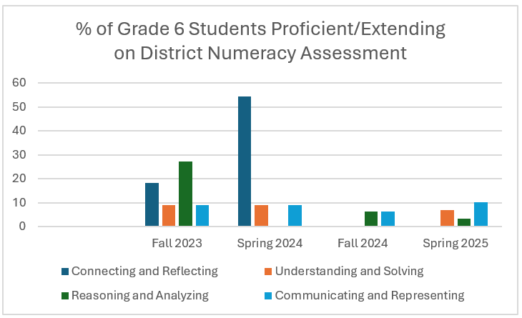
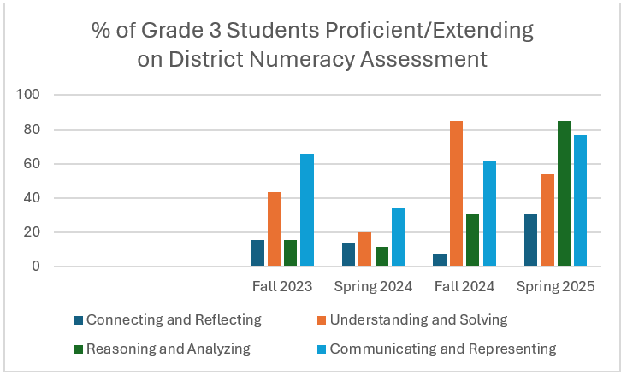


Goal 3: Well-being

Our students will feel a sense of belonging

and can identify adults who care about them.

Aligns with SD 91 priority: Create Student Success: A continued focus on the essential skills of literacy, numeracy, and social emotional well-being.

It is vital that students engage in Social Emotional learning activities to learn and apply skills that help them to understand and manage emotions, set goals, and make responsible decisions. This is the foundation for academic performance, mental wellness, and healthy relationships.
Current reality/What does the data tell us?
The data from the grade 4 learning survey tells us that positive responses to the question "How many adults care about you has been declining. While the 2022-2023 school year saw an uptick, 2023-2024 saw a decline.
2023-2024 responses reflect that while 70% of students feel safe at school and 78% are happy at school, many do not feel welcome (58%), a sense of belonging nor that they are learning to solve problems in a peaceful way.
Our response to the data:
EDS staff feel it is important to foster a culture of respect and integrity to ensure every student feels physically, emotionally, and socially safe at school regardless of their beliefs, gender, race, culture, religion, sexual orientation, or gender identity. The data shows us that we need to explicitly teach social responsibility skills as well as actively work to cultivate a culture of inclusivity and develop positive and caring relationships.
What is next?
Use the WITS program to promote kindness and reduce victimization, and Play is the Way program to promote, emphasize and develop the characteristics we want to see in our students. To develop this character education in both classroom and school-based activities to create students of moral and ethical courage. We will continue to use house teams, buddy groups and monthly assemblies. We will look at engagement surveys with students, families, and staff to measure growth.
Core Competency goal setting and self-reflection allows students to set goals and reflect on Communication (We can speak and listen actively and respectfully), Social Responsibility (We can show respectful and inclusive behaviour as we learn and play) and Creative/Critical Thinking (We can reflect, evaluate, and grow in our own thinking, and actions).
Continue to provide hot lunch through PAC hot lunch day, SD 91 Feeding Futures and daily breakfast through Breakfast Club of Canada grants. Also consider the impact of food insecurity for learners when they are not at school and consider additional programs to support this.
We will continue honour important days such Pink Shirt Day and Share the Love Day while promoting the virtues found in the school motto-d specifically Caring, Acceptance, Respect and Responsibility. We will continue to build a culture of kindness and inclusion.
We are committed to ensuring that all our learners feel seen, valued, and safe, fostering an inclusive environment where everyone is welcomed and supported.
How will we know:
Using the data from the Grade 4 Student Learning Survey, we will see an increase in identifying adults who care, as well as a sense of welcome and belonging.

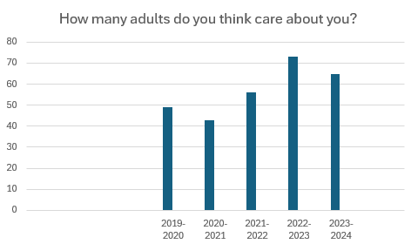
Data: Well-being
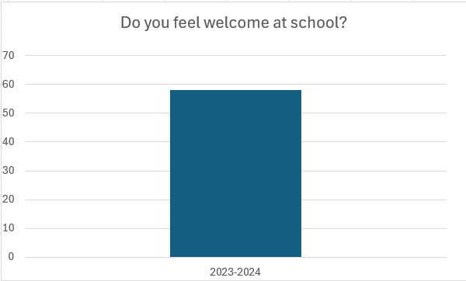

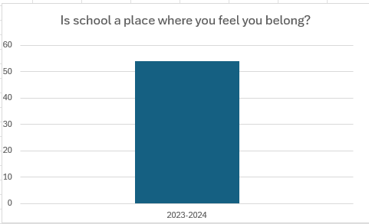
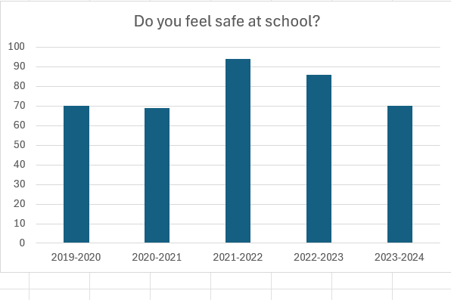

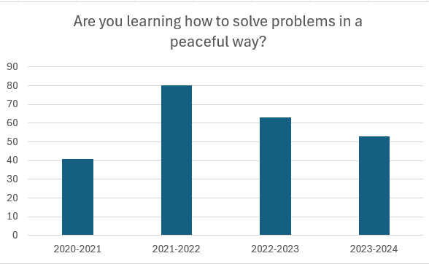
Indigenous Ways of Learning and Knowing
Aligns with SD 91 priority: Honour Diversity
We are committed to integrating Indigenous knowledge and practices into all aspects of our school. Our full time Indigenous Advocate is scheduled into classrooms weekly to ensure our students of Indigenous Ancestry have a consistent connection with a person of Indigenous ancestry to support academic, social, and emotional growth.
We are working to incorporate aspects of Indigenous ways of being into our regular learning and daily activities. This includes practices such as welcoming everyone in Carrier, French, and English, and always honoring Saik’uz Traditional Territory. We honour Indigenous contributions on Remembrance Day and highlight and observe important days such as National Day for Truth and Reconciliation, National Indigenous Peoples Day, and National Day of Awareness for Murdered and Missing Indigenous Women (Red Dress Day).
Our goal is to collaborate with Elders and Knowledge Keepers from Saik’uz First Nation to share their knowledge and skills with students, as well as to visit classrooms regularly for activities that recognize Indigenous culture.

Enhance Connections
Aligns with SD 91 priority: Enhance Connections

Greenhouse and Garden Refurbishment
The school garden and greenhouse provide rich opportunities for hands-on learning. The area is currently needing refurbishment. In collaboration with SD 91 Careers and other community partners, the areas will undergo work in Spring 2025. It is hoped that our garden may become a vital part of districts Farm to School program.

RCMP Liaison Officer
In the 2024-2045 school year, we have been privileged to begin to develop a relationship with our school liaison officer and his colleagues from the Vanderhoof detachment of the RCMP. The goal is to establish regular friendly visits so that our learners will become comfortable and familiar with the RCMP officers. As his schedule permits, our school liaison officer may join us for special events at the school and in the community. We look forward to continuing to strengthen this connection by providing opportunities for our learners to get to know our liaison officer.

Community Support
EDS Students actively support the local community with events such as fundraising and non-perishable donations for food hampers. December activities highlighted the creation and delivery of Christmas cards for a community helper/first responder, or senior.

School Plan - A Living Document
To gain insights and feedback, the following groups have actively participated in the development of this plan:
- Teachers (NTU)
- Support Staff (CUPE)
- EDS Parent Advisory Committee (PAC)

